**NOTE: This is an official document by Indexademics. Unless otherwise stated, this document may not be accredited to individuals or groups other than the club IDX, nor should this document be distributed, sold, or modified for personal use in any way.**

**IDX G9 CHEMISTRY S STUDY GUIDE**

**By Felix**

**Chapter 3**

-Scientific Measurements

**-**a measurement refers to a quantity that has both a number and a unit.

-Scientific Notation

-mx10n

-m: coefficient (1<m<10)

-n: exponent (the times that the decimal point be moved to result m-integer)

-positive exponent: move decimal place rightwards

-negative exponent: move decimal place leftwards

-Scientific notation calculations

-addition and subtraction: move decimal points so that exponents are same)

-e.g. (5.4x103) + (0.80x104) = (5.4x103) + (8.0x103) =13.4x103=1.34x104

-multiplication and division: add/subtract the exponents

-e.g. (2.1x103) x (4.0x107) = 8.4x10-4

-e.g. 3.0x105/6.0x102 = (3.0/6.0) x 105-2 = 5.0x102

-Accuracy: measure of the closeness of a measurement to its truth value.

-Precision: measure of how close a measurement is to another.

-For example:

-Four of five repetitions of a measurement were numerically identical, and the fifth varied from the others in value by less than 1% - Precision

-Eight measurements were spread over a wide range - Precision

- A single measurement is within 1% of the correct value – Accuracy

-Error: the difference between the experimental value and the accepted value

-Percent error is calculated by the formula: 1error1 (absolute value)/accepted value times 100%.

-Significant digits: all the digits of a measurement that are known, plus the last digit that is estimated.

-How to determine how many SF:

-If the decimal point is present, start counting the first nonzero number from left to right till the end.

-If decimal point is absent, start counting the first nonzero number from right to left till the end.

-e.g. 43x109 – 2 significant figures

-e.g. 0.00428377 – 6 significant figures

-Rounding in calculations

-addition and subtraction: result has the same number of decimal places as the measurement with the least decimal place.

-e.g. 313-1.2x103 = -887 = -900 (final result)

-multiplication and division: result has the same number of SF as the measurement with the least SF

-e.g. 3.983x3.5 = 13.9405 = 14 (final result)

-Units of Measurement

-All metric units are based on multiples of 10

-Seven Base SI (Internation system) units

-mass-kilogram, kg

-length-meters, m

-time-second, s

-amount of substance-mole, mol

-temperature-kelvin, K

-electric current-ampere, A

-luminous intensity-candela, Cd

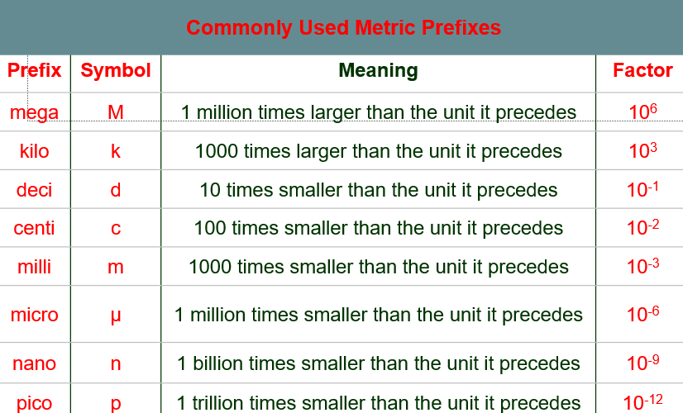

-Units of Volume

-1L=1000mL=1dm3

-1mL=1cm3

-Units of Energy

-K=C+273

-C=K-273

-to be more accurate wise 273.15

-0K is known as absolute zero.

-Density

-formula: Density = mass/volume

-Conversion Factors: ratio of equivalent measurements

-smaller unit is associated with larger number

-larger unit is associated with smaller number

-they are undefined quantities therefore they have an unlimited number of SF

-Dimensional analysis: a way to analyze and solve problems using the units of the measurement

-e.g. expressing 750 nanometers into meter-750 nanometer x 1m/10^9 nm= (7.50x10-7) m

**Chapter 5(After midterms)**

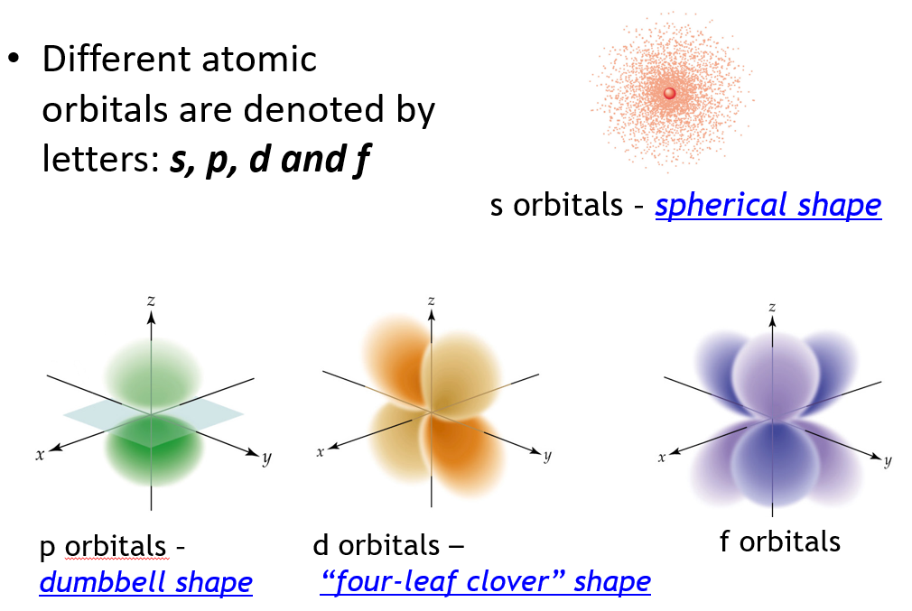

-The principal quantum number, n, always equal the number of sublevels within that principal energy level.

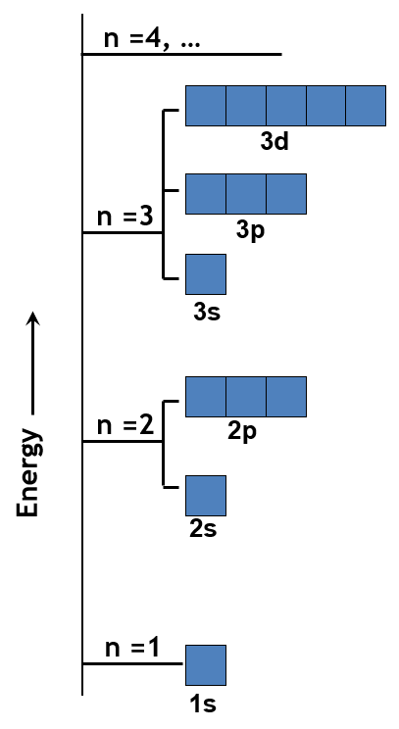

-Each energy level (n) consists of n2 orbitals

-each orbital can contain at most 2 electrons

-therefore, the maximum of electrons an energy level can hold is given by 2n2.

-Electron arrangement in atoms

-the way in which electrons are arranged in various orbitals around the nuclei of atoms are called electron configurations.

-electron configuration is the most stable arrangement of the electrons, indicating the ground state of an atom.

-Four rules/principles

-Aufbau Principle

-electrons occupy the orbitals of lowest energy first

-Energy ranking:

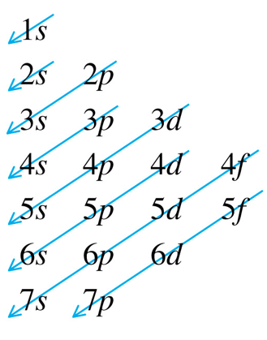

-Pauli Exclusion Principle

-an atomic orbital may describe at most two electrons with the opposite spin.

-Spin is a quantum mechanical property of electrons that are either clockwise

or counterclockwise.

-When electrons with opposite spins occupy an orbital, that orbital is said to be paired.

-Hund’s rule

-electrons occupy orbitals of the same energy in a way that makes the number of electrons with the same spin direction as large as possible.

-e.g. three electrons would occupy three orbitals with equal energy

-Condensed Electron Configurations

-the electron configuration of the nearest noble-gas element (last element of each horizontal period) of lower atomic number is represented by its chemical symbol in brackets.

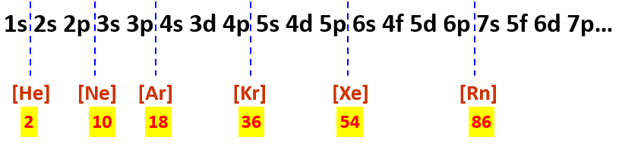

-exceptional electron configurations

-Chromium and Copper

-their electron configuration will be:

-Cr 1*s*22*s*22*p*63*s*23*p*63*d*54*s*1

-Cu 1*s*22*s*22*p*63*s*23*p*63*d*104*s*1